­­

과목명 : IOT시스템응용

담당교수 : 봉진숙

학번 : 20170660

학과 : 컴퓨터공학과

이름 : 김동현

**REPORT**

**1. TextView**

코드) MainActivity.java

package com.dong.textview;  
  
import androidx.appcompat.app.AppCompatActivity;  
  
import android.os.Bundle;  
  
public class MainActivity extends AppCompatActivity {  
  
 @Override  
 protected void onCreate(Bundle savedInstanceState) {  
 super.onCreate(savedInstanceState);  
 setContentView(R.layout.*activity_main*);  
 }  
}

코드) activity_main.xml

<?xml version="1.0" encoding="utf-8"?>  
<androidx.constraintlayout.widget.ConstraintLayout xmlns:android="http://schemas.android.com/apk/res/android"  
 xmlns:app="http://schemas.android.com/apk/res-auto"  
 xmlns:tools="http://schemas.android.com/tools"  
 android:layout_width="match_parent"  
 android:layout_height="match_parent"  
 tools:context=".MainActivity">  
  
 <TextView  
 android:layout_width="wrap_content"  
 android:layout_height="wrap_content"  
 android:text="20170660 김동현"  
 app:layout_constraintBottom_toBottomOf="parent"  
 app:layout_constraintLeft_toLeftOf="parent"  
 app:layout_constraintRight_toRightOf="parent"  
 app:layout_constraintTop_toTopOf="parent" />  
  
</androidx.constraintlayout.widget.ConstraintLayout>

실행 결과)

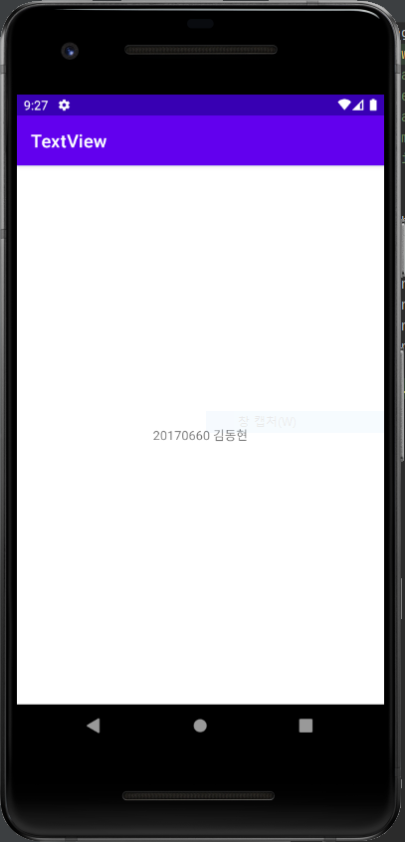

**2. Button3**

코드) MainActivity.java

package com.dong.button3;  
  
import android.content.Intent;  
import android.net.Uri;  
import android.os.Bundle;  
import android.view.View;  
import android.widget.Toast;  
  
import androidx.appcompat.app.AppCompatActivity;  
  
public class MainActivity extends AppCompatActivity {  
  
 @Override  
 protected void onCreate(Bundle savedInstanceState) {  
 super.onCreate(savedInstanceState); // super = 부모가 가진  
 setContentView(R.layout.*activity_main*);  
 }  
  
 public void onButton1Clicked(View v) {  
 Toast.*makeText*(this, "확인1 버튼이 눌렸어요", Toast.*LENGTH_LONG*).show();  
 }  
  
 public void onButton2Clicked(View v) {  
 Intent myIntent = new Intent(Intent.*ACTION_VIEW*, Uri.*parse*("http://m.naver.com"));  
 startActivity(myIntent);  
 }  
  
 public void onButton3Clicked(View v) {  
 Intent myIntent = new Intent(Intent.*ACTION_VIEW*, Uri.*parse*("tel:010-3650-6917"));  
 startActivity(myIntent);  
 }  
  
}

코드) activity_main.xml

<?xml version="1.0" encoding="utf-8"?>  
<androidx.constraintlayout.widget.ConstraintLayout xmlns:android="http://schemas.android.com/apk/res/android"  
 xmlns:app="http://schemas.android.com/apk/res-auto"  
 xmlns:tools="http://schemas.android.com/tools"  
 android:layout_width="match_parent"  
 android:layout_height="match_parent"  
 tools:context=".MainActivity">  
  
 <Button  
 android:id="@+id/button"  
 android:layout_width="wrap_content"  
 android:layout_height="wrap_content"  
 android:onClick="onButton1Clicked"  
 android:text="확인1"  
 app:layout_constraintBottom_toBottomOf="parent"  
 app:layout_constraintEnd_toEndOf="parent"  
 app:layout_constraintStart_toStartOf="parent"  
 app:layout_constraintTop_toTopOf="parent" />  
  
 <Button  
 android:id="@+id/button3"  
 android:layout_width="wrap_content"  
 android:layout_height="wrap_content"  
 android:onClick="onButton2Clicked"  
 android:text="네이버 접속하기"  
 app:layout_constraintBottom_toBottomOf="parent"  
 app:layout_constraintEnd_toEndOf="parent"  
 app:layout_constraintStart_toStartOf="parent"  
 app:layout_constraintTop_toBottomOf="@+id/button" />  
  
 <Button  
 android:id="@+id/button4"  
 android:layout_width="wrap_content"  
 android:layout_height="wrap_content"  
 android:onClick="onButton3Clicked"  
 android:text="전화걸기"  
 app:layout_constraintBottom_toBottomOf="parent"  
 app:layout_constraintEnd_toEndOf="parent"  
 app:layout_constraintStart_toStartOf="parent"  
 app:layout_constraintTop_toBottomOf="@+id/button3" />  
  
</androidx.constraintlayout.widget.ConstraintLayout>

실행 결과)

